Where in the World? Foreign Currency

Answer the questions by using the provided links. You will be using the geography and economy section for each country. Change the color of your answer!

- What are the three border countries of Norway?
- What is the currency of Norway called?

https://www.cia.gov/library/publications/the-world-factbook/geos/no.html

- What is the lowest point in India?
- What is the currency of India called?

https://www.cia.gov/library/publications/the-world-factbook/geos/in.html

- What is a natural hazard in Sweden?
- What is the currency of Sweden called?

https://www.cia.gov/library/publications/the-world-factbook/geos/sw.html

7. What is an Area-comparative for Italy?
8. What is the currency of Italy called?

https://www.cia.gov/library/publications/the-world-factbook/geos/it.html

9. What is the highest point in Japan?
10. What is the currency of Japan called?

https://www.cia.gov/library/publications/the-world-factbook/geos/ja.html

11. What are the natural resources of Malta?
12. What is the currency of Malta called?

https://www.cia.gov/library/publications/the-world-factbook/geos/mt.html

13. What is a natural hazard in South Africa?
14. What is the currency of South Africa called?

https://www.cia.gov/library/publications/the-world-factbook/geos/sf.html

Continue to the 2nd page
15. What is the area of water in Saudi Arabia?
16. What is the currency of Saudi Arabia called?

https://www.cia.gov/library/publications/the-world-factbook/geos/sa.html

17. What is the Area – comparative of the United Kingdom?
18. What is the currency of the United Kingdom?

https://www.cia.gov/library/publications/the-world-factbook/geos/uk.html

19. What is the length of the coastline in Ethiopia?
20. What is the currency of Ethiopia called?

https://www.cia.gov/library/publications/the-world-factbook/geos/et.html

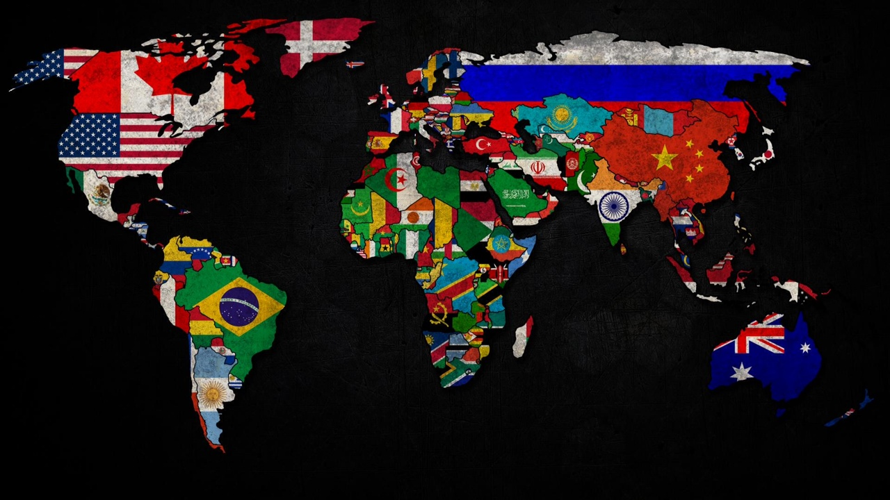
Save as Last-Currency

