Activity 1.5.2 Computer Modeling Fundamentals

Introduction
Do you play with computer games? Have you ever wondered how designers created such objects and then managed to make them look so real? They used three-dimensional modeling, sometimes called 3D. Three-dimensional modeling is used often in the design and creation of many things, from computer games to the chair that you are sitting in.

Look around your room. Every item that you see was first designed and sketched in 3D. Three-dimensional drawing allows you to see an object from different views. When 3D designs are created on a computer, the designer can move an object to where you can even see underneath it or from its back.

On a two-dimensional surface that is flat, such as drawing paper, you must create a visual illusion in order to draw a picture that appears in three-dimensions. This is often done by distorting images using different perspective drawings.
Vanishing Point
Vanishing Point
Vanishing Point
Horizon Line
Horizon Line
Equipment
- GTT notebook
- Pencil
- Computer with 3D modeling software

Procedure
In prior activities you learned about sketching. You were introduced to one- and two-point perspective as well as isometric and orthographic drawing. In a 2D drawing, you are concerned with only the two dimensions of width and length. In a 3D drawing, you are concerned with a third dimension, depth.

In this activity you will use a 3D computer modeling program specifically designed to help you craft 3D models of your drawings.

- Complete the activity below while watching the Computer Modeling Fundamentals Presentation.
- Use your 3D modeling software to complete the activities.
- Make sure you get your teacher’s initials where necessary before continuing on in the activity.

Computer Modeling Fundamentals
- Label the parts of the screen shown below.
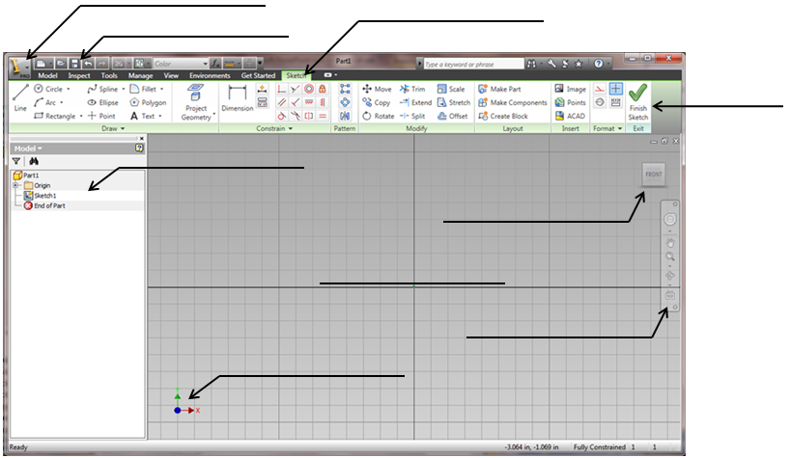

- Briefly describe what each section of the screen is for.
- Application Menu

- Quick Access Toolbar

- Ribbon

- Ribbon Tabs

- View Cube

- Navigation Bar

- Browser

- 3D Indicator

- Graphics Window

- Explain the purpose of each of the mouse buttons in your 3D modeling program.

- What is a geometric constraint and how do you get to the geometric constraint menu in the software?

- Complete the chart below with the missing symbol, constraint, or definition:

Perpendicular
Parallel
Touches at one point only
Smooth
Constrains 2 points or point to curve
Arc or Circle shares center point
2 lines lie along the same line
Equal
Vertical
Points or curves stay fixed in place
Objects align symmetrically about a line

- Create a sketch on the computer that uses several different sketching tools. Create some constraints to force objects to be parallel, tangent, equal, etc. Show your sketch to your teacher.
Teacher initials: ___________________
- The dynamic viewing functions are used to zoom and pan your screen. You can also use your mouse wheel to do this. Explain what each of the tools below is used for.

- The Precise Input toolbar is used when you know the coordinates you want to plot. Show your completed sketch using the coordinates from Activity 1.5.1 The Coordinate System and Descriptive Geometry to your teacher.
Teacher initials: ___________________

Conclusion
- Many different icons enable you to create an object in the 3D modeling program. What are two that you have used and how were they helpful?

- Why is it important to use constraints when sketching with your 3D modeling program?

- Which constraints showed up while you were sketching?

- Which constraints did you add to your sketch?

- Why didn’t these show up automatically?

- Explain the difference between zoom and pan when using 3D modeling program and describe two ways that you can perform both.

